Annual
Friends of Connecticut Libraries
Awards 2024

The Friends of Connecticut Libraries Awards recognize outstanding local
Friends organizations, groups, and individuals.

Awards and Criteria: Friends of Connecticut Libraries (FOCL) present three types of awards each year: Group, Individual and Focused Project. Each award type is presented in three population categories (see reverse side of this form). You can nominate a person, a group of people or a Friends group and you can submit more than one nomination.

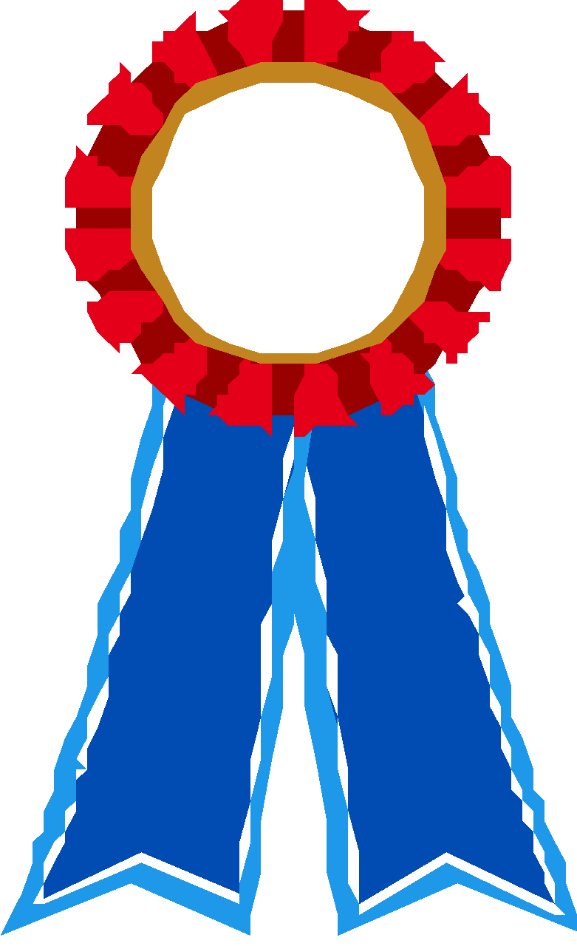 Friends Group Award | Individual Achievement | Focused Project
Focused on the total effort of the Friends Group | One or two individuals | A focused project is usually accomplished or orchestrated by a small group or committee
Accomplished in the previous year | Efforts culminate in the award year | Efforts culminated in the award year
A year that:  - Accomplished major goals in support of the library and the community  - Provided new and/or innovative programs  - Raised significant money or awareness by attracting the community to the library | Significant contributions such as:  - Lifetime achievement  - Exceptional library service  - Substantial increase in book sale or fundraising profits  - A great idea implemented | A project such as:  - Successful membership drive  - A great idea implemented  - An outstanding use of media  - Raised significant money or awareness by attracting the community to the library

- Nominees must belong to Friends groups that are members of FOCL.
- Award winning Friends groups, individuals, or projects shall be ineligible for the same award for a period of 3 years.
- The committee reserves the right not to give an award in a specific category or to give additional awards if merited.

Nomination Instructions: Nominations must be completed by April 30, 2024 and should include:
- A brief (no more than 1000 words) summary of the activities during the preceding year for the Friends award or of the accomplishments of the group or individual(s) that culminated or reached a significant milestone in the preceding year. This summary, while concise, should convey the scope and benefits of the efforts. E-mail the summary to Pam Monahan:
foclawards@gmail.com
- A completed form (see the reverse side of this page) and supporting materials (press releases, clippings, promotional materials, etc.) although they are not required, should be mailed to:
Pam Monahan
53 Conrad Street, Apt. 31B
Naugatuck, CT 06770
- Supporting materials are not returnable and may be used in exhibits and the FOCLPOINT newsletter

Nominee (Group/Individual) Phone
Address City Zip
E-Mail Address (if available) _______________________________________________________

Nominated by Phone_________________
Address_________________________________________ City Zip_________________
E-Mail Address (if available) _______________________________________________________
*** Please provide a phone number the Awards Committee can use to reach you if they have questions***

Library Name Phone_______________
Address_________________________________________ City___ Zip__________________
E-Mail Address (if available) ________________________________________________________

Select category and population (Check One)

Friends Group Award | Individual Achievement | Focused Project
For a municipality with a population of: | For a municipality with a population of: | For a municipality with a population of:
_____ Less than 15,000  _____ 15,000 to 25,000  _____ Over 25,000 | _____ Less than 15,000  _____ 15,000 to 25,000  _____ Over 25,000 | _____ Less than 15,000  _____ 15,000 to 25,000  _____ Over 25,000

Mailed material must be postmarked by April 30, 2024, and sent to:
Pam Monahan
53 Conrad Street, Apt. 31B
Naugatuck, CT 06770
If you have any questions regarding the awards, do not hesitate to call me at
203-525-5674 or write me at foclawards@gmail.com

Awards will be presented to the winners at FOCL’s Annual Meeting on June 15, 2024
The meeting will be held at the

Avon Public Library, Avon, CT
(Program to be announced)

The meeting will begin with refreshments at 9:30 a.m. and ending about 1:00 p.m.

Mark your calendars. Winners should plan to attend.
It is always a great time honoring the winners and listening to the success stories.

